Step 1: create Folder in any location

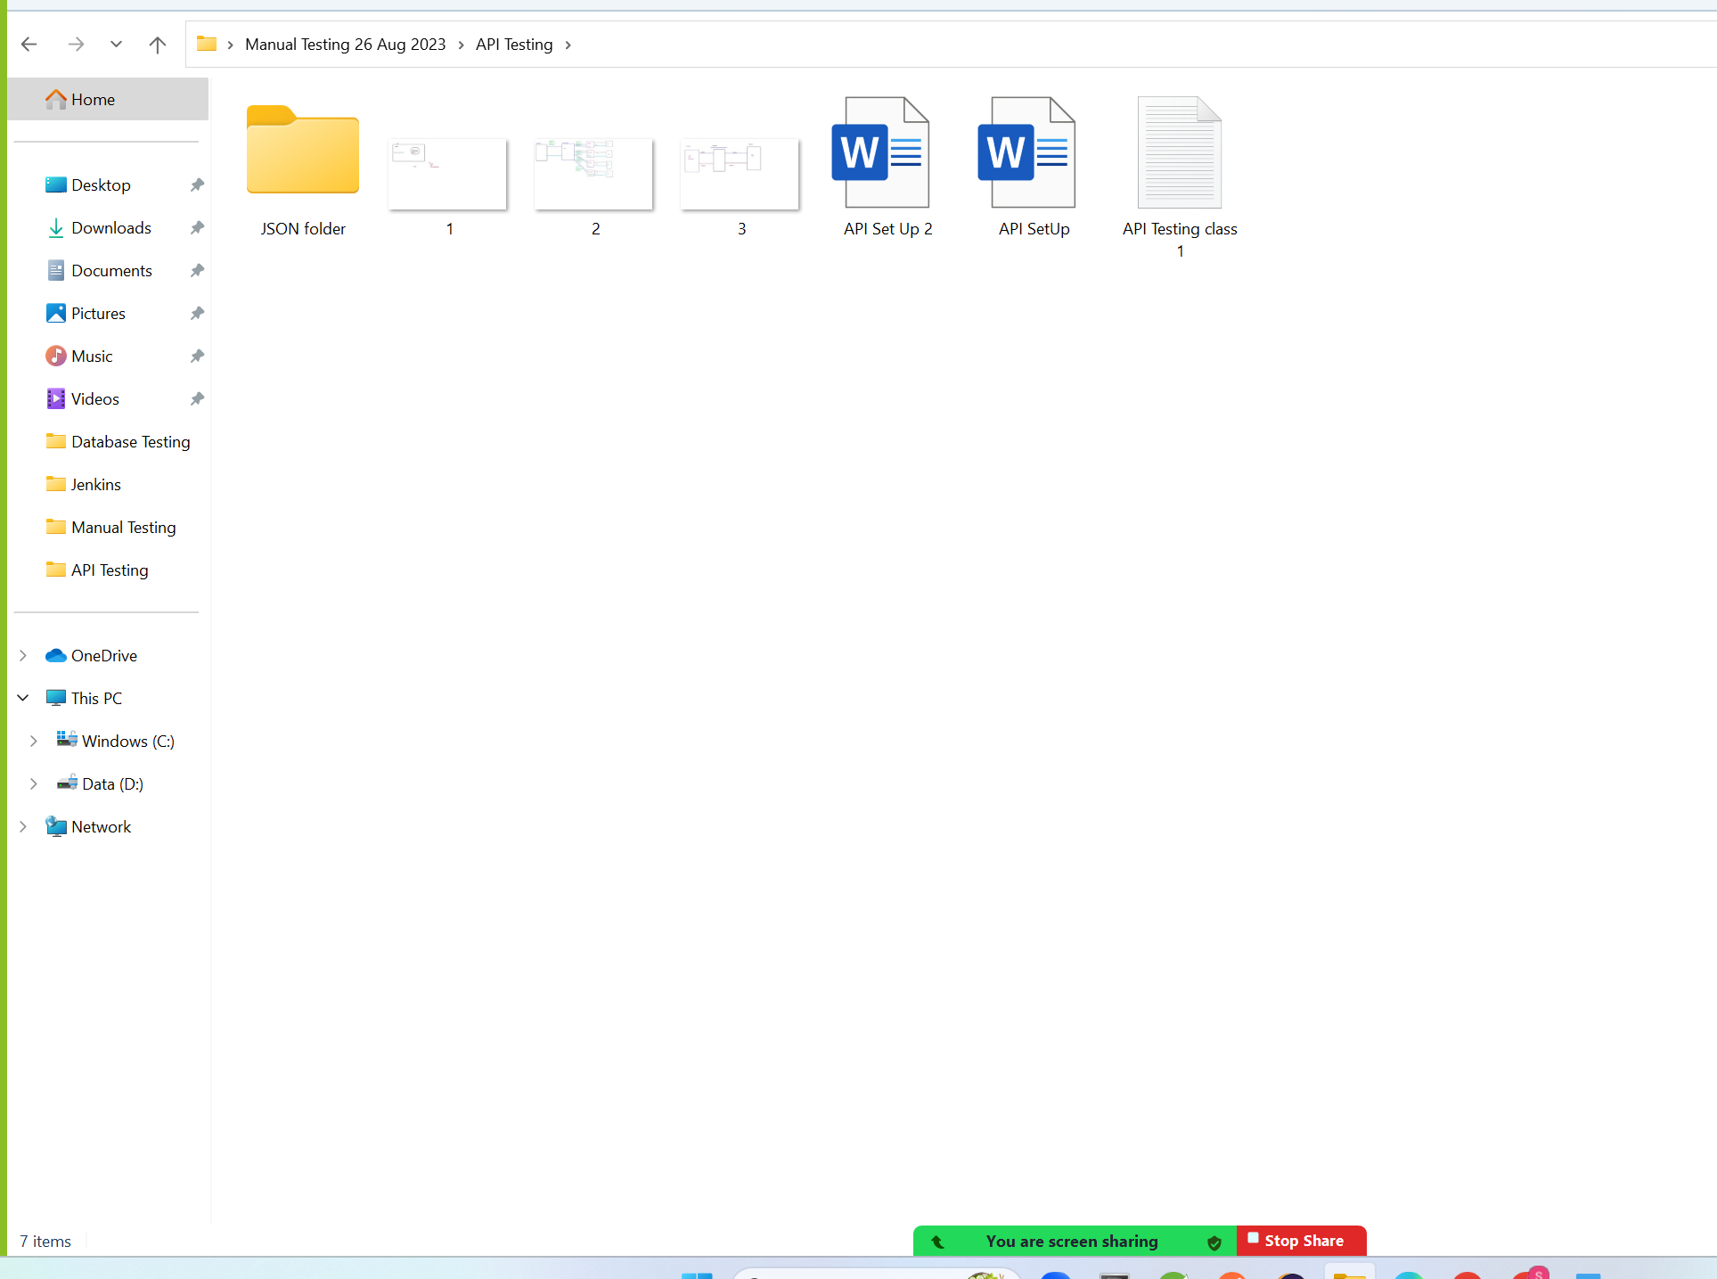

Step 2: open folder in Power shell command line

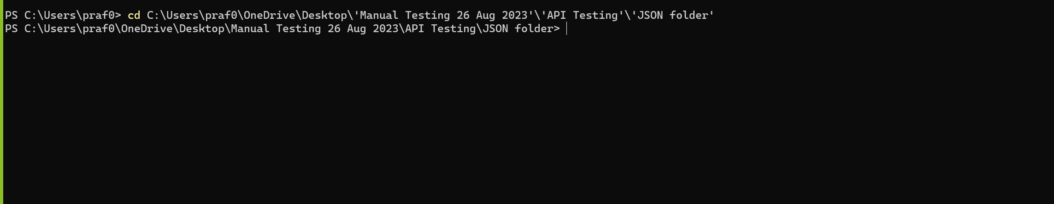

Step 3: Run below command on folder created location

Set-ExecutionPolicy -Scope CurrentUser Unrestricted

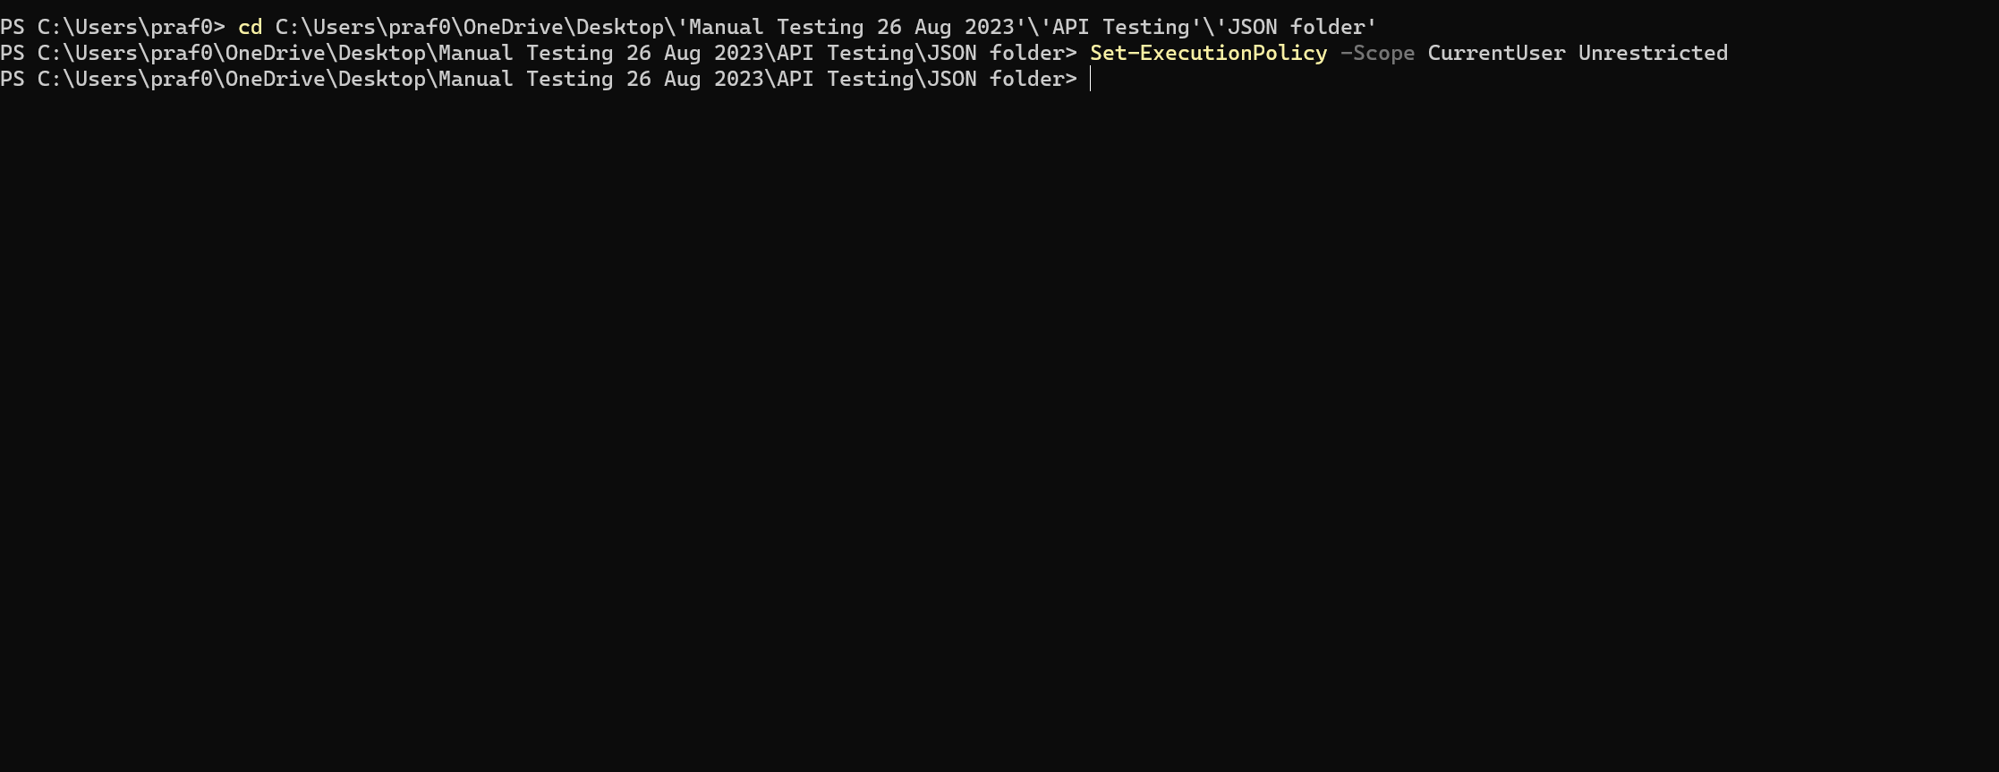

**Close the power shell Command line**

Step 4: Open a created Folder (JSON Server) In VS Code

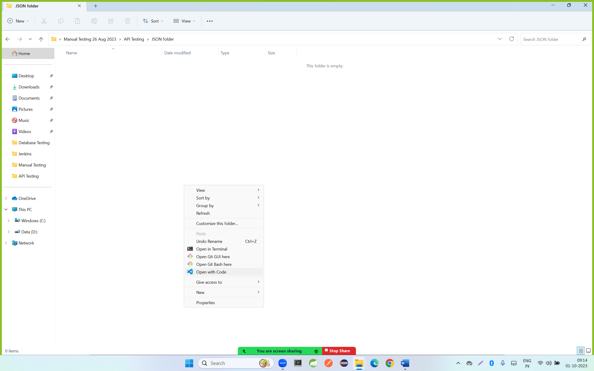

Step 5: create db.json file in above folder location and paste the below code

|  |
| --- |
| {      "employees":      [          {              "id": 1,              "fname":"Rajesh",              "lname" :"Patil",              "mobileNo":"3245553435",              "address":"Pune",              "emailId":"rajesh@gmail.com"          },          {              "id": 2,              "fname":"Reshma",              "lname" :"Patil",              "mobileNo":"32453435",              "address":"Mumbai",              "emailId":"reshma@gmail.com"          }      ]  } |

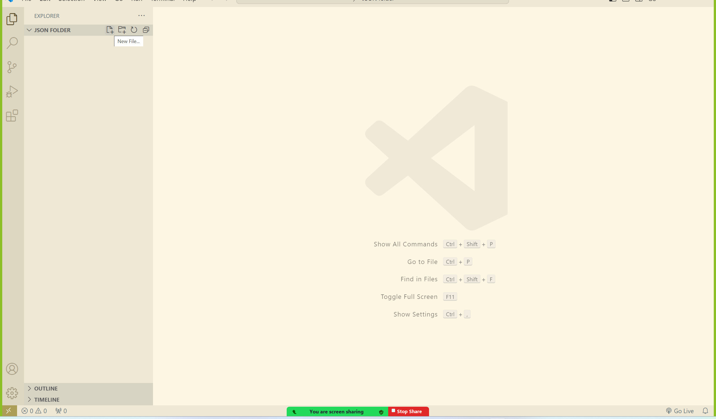

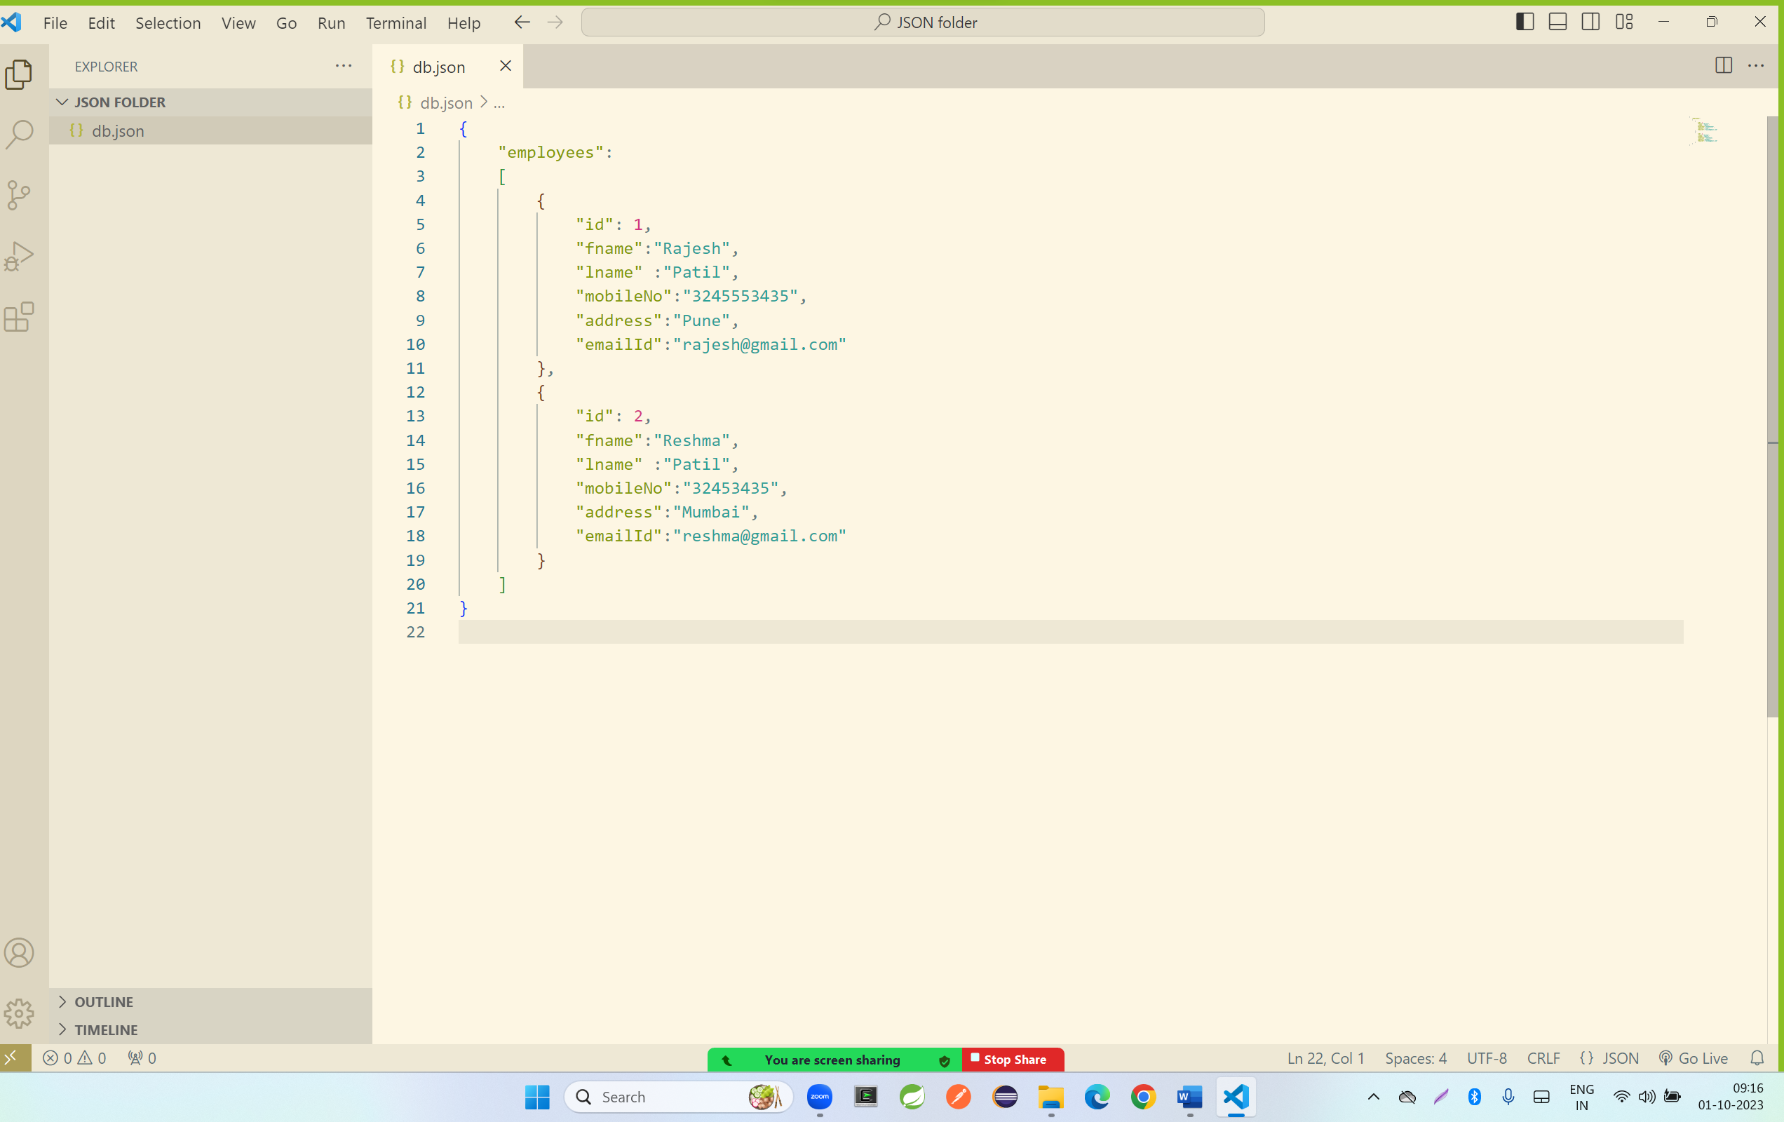

Step 6: click on terminal and enter the below command

npm install -g json-server

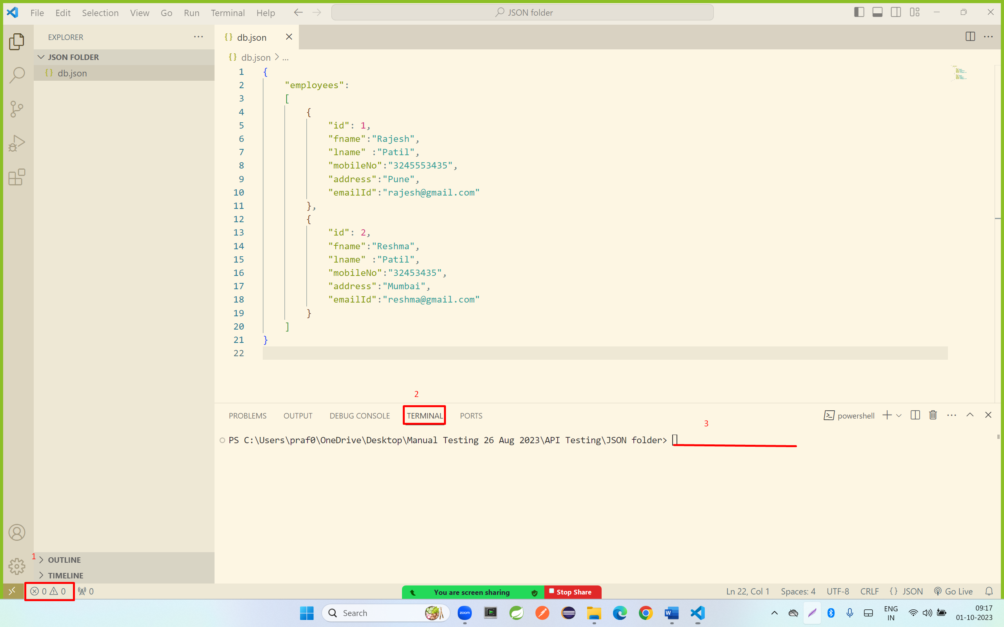

Output:

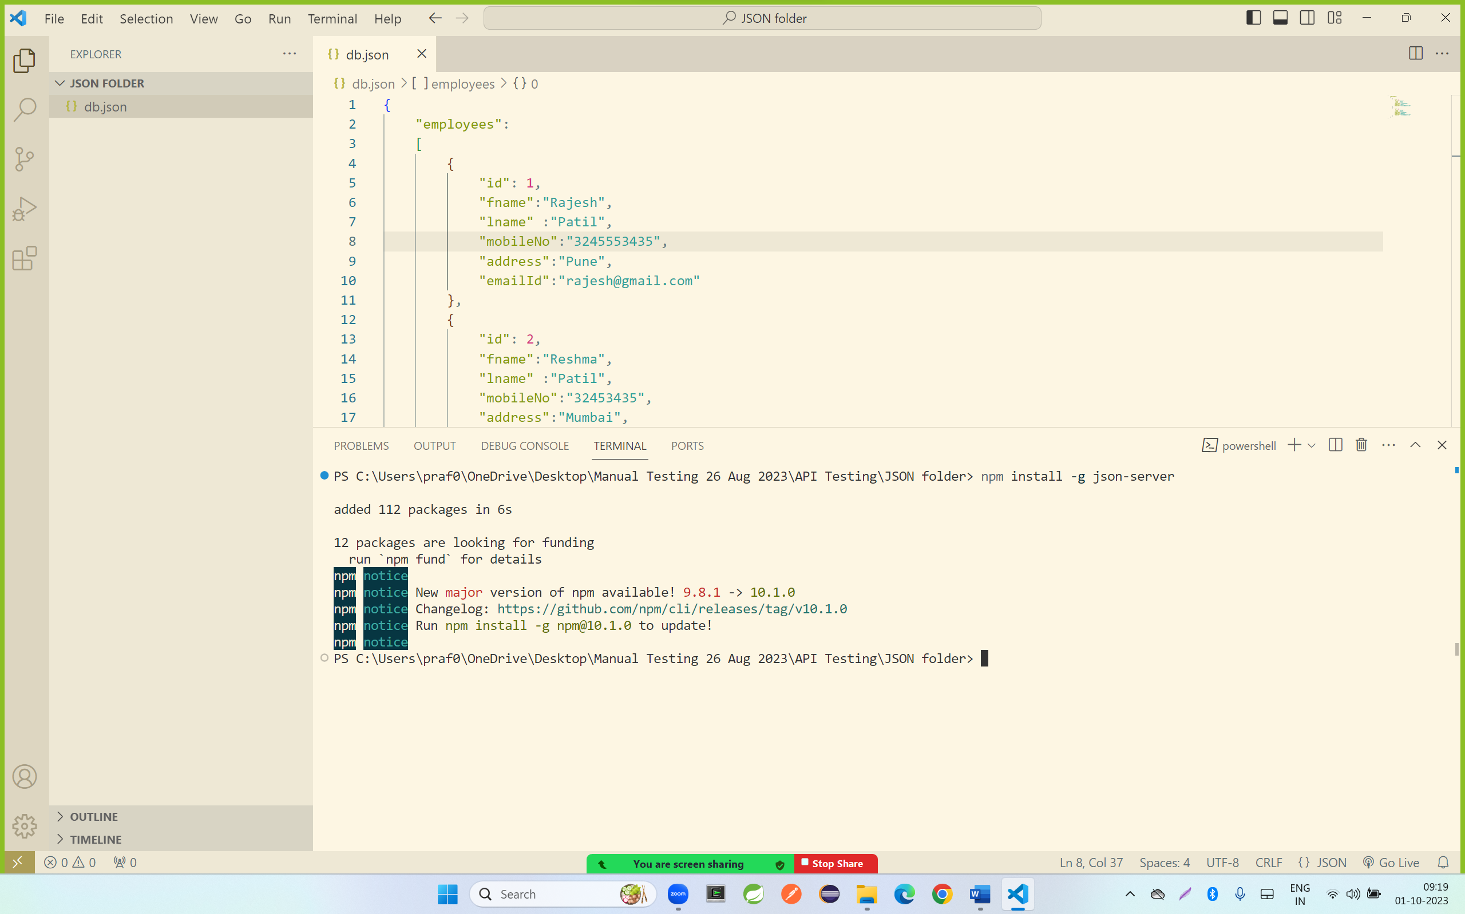

Step 7: enter the below command

json-server --watch db.json

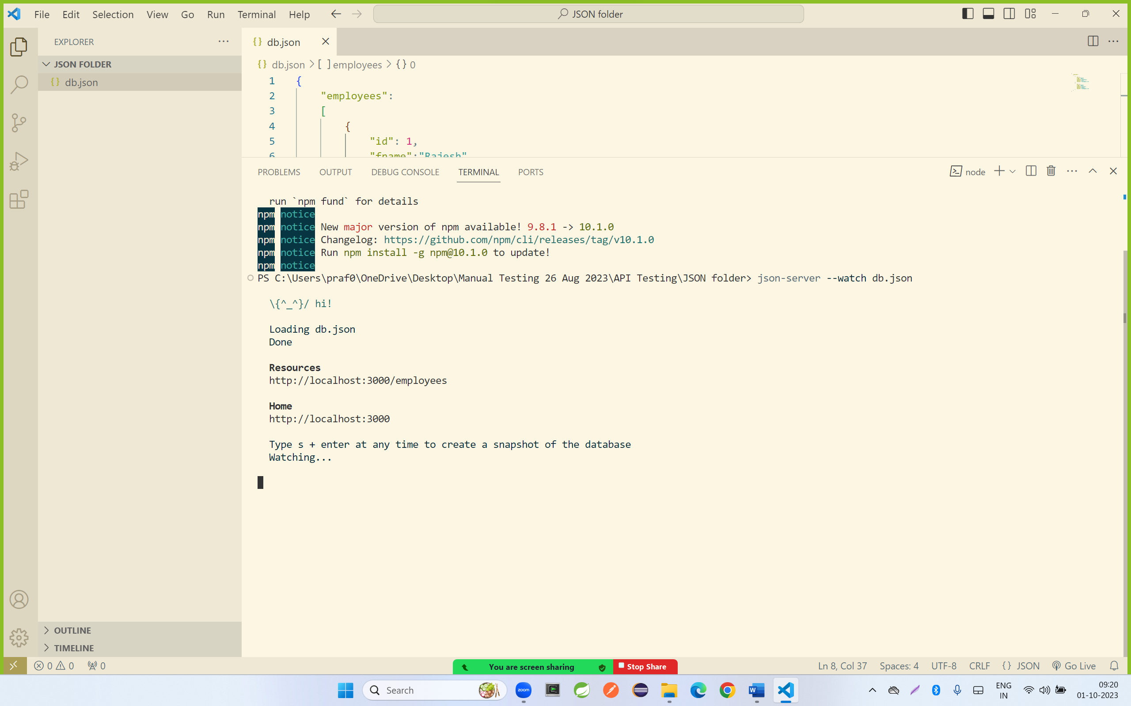

Step 8: open a browser and hit the below url

<http://localhost:3000/employees>